**Age After 10 Years**

Write a program that ask for your age now and calculates your age after 10 years.

|  |  |  |  |
| --- | --- | --- | --- |
|  | **Input** | **Output** | |
| 19  ---------------  20 | You will be 29 years old after 10 years.  ---------------------------------------------------------  You will be 30 years old after 10 years. |

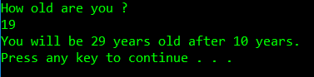

**Some Hints !?!**

1. Add new project in the Solution from the Task in 01.BlankSolution.docx.
2. The project must be Console App !!!
3. This screenshot is from my AgeAfter10YearsDemo console application. Your program must work the same way.

